ERD DATABASE DIAGRAM SPECIFICATION

ONLINE CLOTHING STORE SYSTEM
Online Clothing Store
DGM-04
Database entities, primary keys, foreign keys, relationships, and integrity constraints.
Version 1.0
September 30, 2026
UEF SHOP

ERD Database Diagram Specification
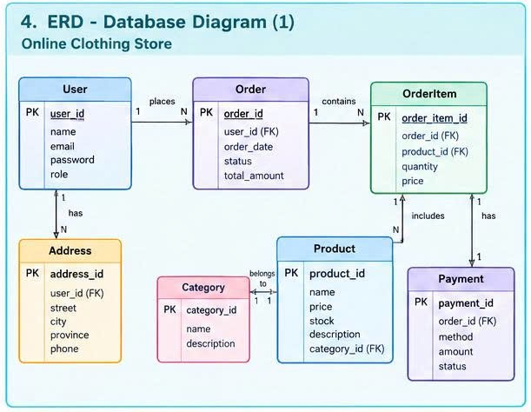
Figure 1. ERD Database Diagram for the Online Clothing Store system

Data Objectives
The ERD maps business concepts to seven relational tables: User, Address, Order, OrderItem, Product, Category, and Payment. The model supports retrieval of order history, delivery addresses, product details, and payment status.

Entity Dictionary
Entity | Keys | Other Attributes | Purpose
User | PK user_id | name, email, password, role | Stores customer and administrator accounts.
Address | PK address_id  FK user_id | street, city, province, phone | Stores one or more delivery addresses for a User.
Order | PK order_id  FK user_id | order_date, status, total_amount | Stores the order header for a purchase transaction.
OrderItem | PK order_item_id  FK order_id  FK product_id | quantity, price | Stores product line items and the price captured at order time.
Product | PK product_id  FK category_id | name, price, stock, description | Stores products and current inventory.
Category | PK category_id | name, description | Groups products for browsing and filtering.
Payment | PK payment_id  FK order_id | method, amount, status | Stores payment information associated with an Order.

Data Relationships
Relationship | Cardinality | Foreign Key and Rule
User - Address | 1:N | Address.user_id -> User.user_id; deleting a User must handle related Address records.
User - Order | 1:N | Order.user_id -> User.user_id; do not hard-delete a User that already has an Order.
Order - OrderItem | 1:N | OrderItem.order_id -> Order.order_id; OrderItem depends on the lifecycle of Order.
Product - OrderItem | 1:N | OrderItem.product_id -> Product.product_id; a product referenced by an order should be hidden rather than hard-deleted.
Category - Product | 1:N | Product.category_id -> Category.category_id.
Order - Payment | 1:1 | Payment.order_id -> Order.order_id and must be UNIQUE.

Domains and Integrity Constraints
Field | Suggested Type | Constraint
User.email | varchar(255) | NOT NULL, UNIQUE; normalize to lowercase before comparison.
User.password | varchar(255) | Store a password hash; never store a plaintext password.
User.role | varchar(20) | CHECK role IN ('customer','admin').
Order.order_date | datetime | NOT NULL; default to the creation timestamp.
Order.status | varchar(20) | Pending, Processing, Shipped, Completed, or Canceled.
Order.total_amount | decimal(12,2) | CHECK total_amount >= 0.
OrderItem.quantity | int | CHECK quantity > 0.
OrderItem.price | decimal(12,2) | CHECK price >= 0; historical price does not automatically change with Product.price.
Product.stock | int | CHECK stock >= 0.
Payment.method | varchar(30) | COD, Card, or EWallet within the demo scope.
Payment.status | varchar(20) | Pending, Paid, Failed, or Refunded.

Order Creation Transaction
When checkout succeeds, the Database must first insert Order to obtain order_id, insert all OrderItem records, insert Payment, and update Product.stock. These steps must execute in one transaction. If any step fails, the transaction must roll back so that no Order is left without line items, no orphan Payment exists, and inventory is not reduced incorrectly.

